x
Database Normalization Process
Un-Normalize Form

Step 1:
- Present data in tabular format, where each cell has a single value
- Eliminate repeating group & nulls by making sure that each attribute contains an appropriate data value
- Identify the Primary Keys
1st Normal Form
3rd Normal Form

Step 2:
- Identify All Dependencies
- Remove partial dependency
2nd Normal Form
Step 3:
- Remove Transitive Dependencies

Given the un-normalized form (UNF), normalized it into third normal form (3NF)
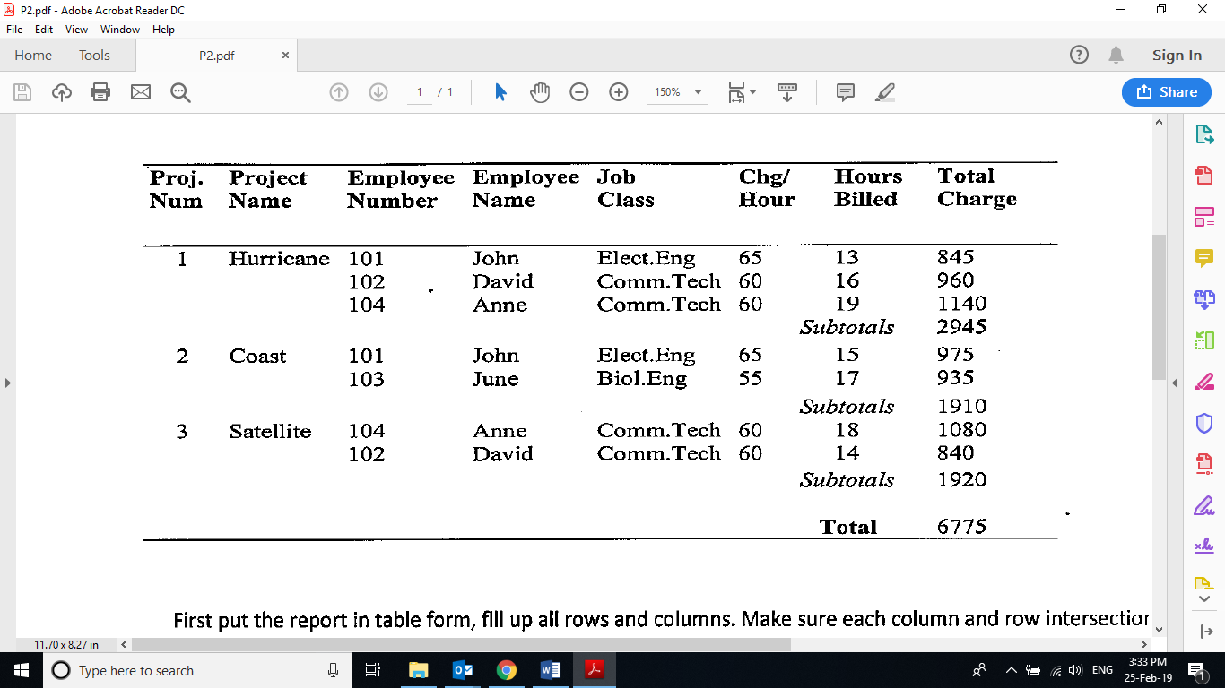

Present the data in table form, fill up all rows and columns. Ensure each row and intersection has only one value
ProNum | ProName | EmpNum | EmpName | JobClass | ChgHour | HourBill | TotChar | SubTot
1 | Hurricane | 101 | John | Elect.Eng | 65 | 13 | 845 | 2945
1 | Hurricane | 102 | David | Comm.Tech | 60 | 16 | 960 | 2945
1 | Hurricane | 104 | Anne | Comm.Tech | 60 | 19 | 1140 | 2945
2 | Coast | 101 | John | Elect.Eng | 65 | 15 | 975 | 1910
2 | Coast | 103 | June | Biol.Eng | 55 | 17 | 935 | 1910
3 | Satelite | 104 | Anne | Comm.Tech | 60 | 18 | 1080 | 1920
3 | Satelite | 102 | David | Comm.Tech | 60 | 14 | 840 | 1920

Identify Primary keys: ProNum&EmpNum
The table is now in first normal form (1NF)
Change to second normal form (2NF)
Primary keys: ProNum&EmpNum (in most cases, there will be more than 1 attributes known as composite PK)
Identify all dependencies. Remove partial dependency (exists when table has composite PK)
Make sure that each non-key attributes / non-determinant / non-PK is fully dependent on its determinant (PK)
Remain at original table
Form new table
Form new table
Composite PK | Non-key attributes | Check List | Action
ProNum&EmpNum | ProName | Is ProName fully dependent on both (ProNum&EmpNum)?  Answer: No, ProName depend on ProNum, not EmpNum | Partial dependency exists. Remove ProName together with its determinant (ProNum) to form a new table.
ProNum&EmpNum | SubTot | Is SubTot fully dependent on both (ProNum&EmpNum)?  Answer: No, SubTot depend on ProNum, not EmpNum | Partial dependency exists. Remove SubTot together with its determinant (ProNum) to form a new table.
ProNum&EmpNum | EmpName | Is EmpName fully dependent on both (ProNum&EmpNum)?  Answer: No, EmpName depend on EmpNum, not ProNum | Partial dependency exists. Remove EmpName together with its determinant (EmpNum) to form a new table.
ProNum&EmpNum | JobClass | Is JobClass fully dependent on both (ProNum&EmpNum)?  Answer: No, JobClass depend on EmpNum, not ProNum | Partial dependency exists. Remove JobClass together with its determinant (EmpNum) to form a new table.
ProNum&EmpNum | ChgHour | Is ChgHour fully dependent on both (ProNum&EmpNum)?  Answer: No, ChgHour depend on EmpNum, not ProNum | Partial dependency exists. Remove ChgHour together with its determinant (EmpNum) to form a new table.
ProNum&EmpNum | HourBill | Is HourBill fully dependent on both (ProNum&EmpNum)?  Answer: Yes, HourBill depend on both (ProNum&EmpNum) | Full dependency exists, therefore no action needed.  HourBill remains in the original table with its determinant (ProNum&EmpNum)
ProNum&EmpNum | TotChar | Is TotChar fully dependent on both (ProNum&EmpNum)?  Answer: Yes, TotChar depend on both (ProNum&EmpNum) | Full dependency exists, therefore no action needed.  TotChar remains in the original table with its determinant (ProNum&EmpNum)

Tables in second normal form (2NF)
ProNum | ProName | SubTot
1 | Hurricane | 2945
2 | Coast | 1910
3 | Satelite | 1920
EmpNum | EmpName | JobClass | ChgHour
101 | John | Elect.Eng | 65
102 | David | Comm.Tech | 60
103 | June | Biol.Eng | 55
104 | Anne | Comm.Tech | 60

ProNum | EmpNum | HourBill | TotChar
1 | 101 | 13 | 845
1 | 102 | 16 | 960
1 | 104 | 19 | 1140
2 | 101 | 15 | 975
2 | 103 | 17 | 935
3 | 104 | 18 | 1080
3 | 102 | 14 | 840

The tables are now in second normal form (2NF)

Convert to third normal form (3NF)
Identify transitive dependency (if any) then remove it, else the tables are already in third normal form (3NF)
Transitive dependency occurs when a non-key attribute is dependent on another non-key attribute
In this example, transitive dependency exists: EmpNum > JobClass > ChgHour (ChgHour is transitively dependent on EmpNum)
ChgHour (which is a non-key attribute) is dependent on JobClass (which is also a non-key attribute), because JobClass determines ChgHour
Therefore, remove JobClass & ChgHour to form a new table. However, JobClass need to remain in Employee table as a reference
Tables in third normal form (3NF)

ProNum | ProName | SubTot
1 | Hurricane | 2945
2 | Coast | 1910
3 | Satelite | 1920
EmpNum | EmpName | JobClass
101 | John | Elect.Eng
102 | David | Comm.Tech
103 | June | Biol.Eng
104 | Anne | Comm.Tech

ProNum | EmpNum | HourBill | TotChar
1 | 101 | 13 | 845
1 | 102 | 16 | 960
1 | 104 | 19 | 1140
2 | 101 | 15 | 975
2 | 103 | 17 | 935
3 | 104 | 18 | 1080
3 | 102 | 14 | 840

JobClass | ChgHour
Elect.Eng | 65
Comm.Tech | 60
Biol.Eng | 55

The tables are now in third normal form (3NF), normalization process ends.
Now you can implement the database in the DBMS, you may make further changes to the tables in 3NF such as below
Implement the tables in database server
You can make further changes by adding/modifying PK & FK
Project Employee
ProNum (PK) | ProName | SubTot
1 | Hurricane | 2945
2 | Coast | 1910
3 | Satelite | 1920
EmpNum (PK) | EmpName | JobClassID (FK)
101 | John | J01
102 | David | J02
103 | June | J02
104 | Anne | J03

ProjectWork Rate
ID (PK) | ProNum (FK) | EmpNum (FK) | HourBill | TotChar
01 | 1 | 101 | 13 | 845
02 | 1 | 102 | 16 | 960
03 | 1 | 104 | 19 | 1140
04 | 2 | 101 | 15 | 975
05 | 2 | 103 | 17 | 935
06 | 3 | 104 | 18 | 1080
07 | 3 | 102 | 14 | 840
JobClassID (PK) | JobClass | ChgHour
J01 | Elect.Eng | 65
J02 | Comm.Tech | 60
J03 | Biol.Eng | 55

